GOLDVISTA JEWELLERS RETAIL ANALYTICS
Business Intelligence Project Report
Prepared by: Ragina V
Tools Used: PostgreSQL | Excel | Power BI | GitHub
Table of Contents
- Executive Summary
- Business Background
- Business Objectives
- Project Architecture
- Data Sources
- Data Cleaning & Transformation
- Data Model & Star Schema
- SQL Analysis – Eight Business Challenges
- Power BI Dashboard Development
- Dashboard Insights
- Key Business Findings
- Business Recommendations
- Limitations
- Future Enhancements
- Conclusion
- Appendix (DAX Measures & SQL Highlights)
1. Executive Summary
GoldVista Jewellers required a centralized analytics solution capable of monitoring sales performance, customer behaviour, branch productivity, payment collections, product trends, and old gold buy-back operations across multiple branches.
The objective of this project was to transform transactional data into actionable business intelligence through SQL-based analysis and interactive Power BI dashboards.
The final solution consists of six executive dashboards supported by optimized SQL views and a dimensional data model, enabling management to make faster and more informed decisions.
2. Business Background
GoldVista Jewellers operates a multi-branch retail jewellery business offering products across multiple categories and karats. The organization faced several reporting challenges:
- Manual reporting process
- Lack of centralized KPIs
- No branch comparison framework
- Limited customer analytics
- Poor visibility into returns and buy-back operations
- Difficulty monitoring salesperson performance
This project addresses these challenges through an integrated BI solution.
3. Business Objectives
The project aims to:
- Build a centralized reporting platform
- Monitor executive KPIs
- Compare branch performance
- Analyze product profitability
- Understand customer behaviour
- Track return and buy-back trends
- Evaluate payment patterns
- Measure salesperson effectiveness
4. Project Architecture
Source Data (Transactional Database) ↓ PostgreSQL ↓ SQL Cleaning Views ↓ Star Schema Data Model ↓ Power BI Semantic Model ↓ Interactive Dashboards ↓ Business Decision Making
5. Data Sources
The solution integrates the following datasets:
- Sales Transactions
- Customer Master
- Branch Master
- Item Master
- Karat Master
- Payment Transactions
- Old Gold Purchases
- Date Dimension
6. Data Cleaning & Transformation
Data preparation included:
- Duplicate removal
- Null value handling
- Standardized data types
- Calculated purity and discount metrics
- Derived financial year and reporting periods
- Clean reporting views (vw_sales_clean, vw_payment_clean, vw_old_gold_clean)
This ensured consistency and improved reporting performance.
7. Data Model & Star Schema
The reporting model follows a star schema design.
Fact tables:
- Sales
- Payments
- Old Gold Purchases
Dimension tables:
- Date
- Branch
- Customer
- Item
- Karat
- Salesperson
This structure improves query performance and simplifies DAX calculations.
8. SQL Analysis – Eight Business Challenges
Challenge 1: Executive Performance Analysis
Business Objective: Provide management with a single view of overall company performance.
Key KPIs: Total Revenue, Invoice Count, Total Weight Sold, Active Customers, Making Charge Revenue, Average Invoice Value, Return Rate, Old Gold Value.
SQL Approach: Created summary views to aggregate sales, customer, payment, and old gold transactions.
Findings:
- Revenue is heavily driven by 22K jewellery sales.
- Average invoice value remained stable across the reporting period.
- Return rate was relatively low at approximately 1.7%.
- Old gold transactions contributed additional business value.
Business Impact: Management can monitor company performance through a single executive dashboard.
Recommendation: Track these KPIs monthly and set branch-level performance targets.
Challenge 2: Branch Performance Analysis
Business Objective: Identify the highest and lowest performing branches.
Key KPIs: Revenue, Invoice Count, Average Transaction Value, Weight Sold, Return Rate, Branch Ranking.
SQL Approach: Aggregated sales transactions by branch and calculated revenue contribution percentages.
Findings:
- Revenue is concentrated among a few branches.
- Branch 16 generated the highest revenue.
- Branch 18 recorded the highest Average Transaction Value.
- Some branches generated high volume but lower revenue.
Business Impact: Highlights operational differences across branches.
Recommendation: Replicate best-performing branch strategies and review underperforming branches.
Challenge 3: Sales & Product Performance Analysis
Business Objective: Understand which products and categories drive revenue.
Key KPIs: Revenue by Item Type, Revenue by Category, Revenue by Karat, Making Charge Revenue, Gross Weight Sold.
SQL Approach: Created product-level revenue analysis using item dimensions and sales facts.
Findings:
- Chains and Gold Bars generated significant revenue.
- 22K jewellery dominates sales.
- Certain item categories contribute high revenue despite lower sales volume.
Business Impact: Improves inventory planning and merchandising decisions.
Recommendation: Increase stock allocation for high-performing categories and reduce slow-moving inventory.
Challenge 4: Customer Intelligence Analysis
Business Objective: Understand customer purchasing behaviour.
Key KPIs: One-Time Customers, Repeat Customers, Repeat Purchase Rate, Customer Lifetime Value (CLV), Average Days Between Purchases, Cohort Retention.
SQL Approach: Used customer transaction history and window functions to identify purchasing patterns.
Findings:
- One-time customers account for approximately 84% of the customer base.
- Repeat customers represent only about 16%.
- Repeat customers spend nearly four times more than one-time buyers.
- Average time between first and second purchase is approximately 9 days.
Business Impact: Customer retention represents a significant growth opportunity.
Recommendation: Introduce loyalty programs and targeted marketing campaigns.
Challenge 5: Returns Analysis
Business Objective: Identify return trends and their financial impact.
Key KPIs: Return Rate (%), Return Value, Return Weight, Return Rate by Branch, Return Rate by Karat, Return Rate by Product Type.
SQL Approach: Analyzed return transactions and compared them against total sales.
Findings:
- Overall return rate is approximately 1.7%.
- Branch 06 recorded the highest return value rate.
- 22K jewellery showed a higher return tendency than 24K products.
- Rings experienced higher return rates compared to other item types.
Business Impact: Returns directly reduce profitability.
Recommendation: Investigate return causes in high-return branches and product categories.
Challenge 6: Old Gold Buy-Back Analysis
Business Objective: Evaluate the importance of old gold transactions.
Key KPIs: Old Gold Value, Old Gold Weight, Branch Contribution, Purity Distribution, Customer Participation.
SQL Approach: Analyzed old gold purchase transactions and linked them to sales activity.
Findings:
- Old gold transactions contribute significantly to business volume.
- Some branches generate substantially more old gold activity.
- Certain salespersons rely heavily on old gold-driven sales.
Business Impact: Old gold programs generate additional customer engagement and sales opportunities.
Recommendation: Expand buy-back promotions and integrate them into marketing campaigns.
Challenge 7: Payment Behaviour Analysis
Business Objective: Understand customer payment preferences.
Key KPIs: Payment Mode Share, Monthly Payment Trends, Branch-wise Payment Mix, Cash vs Non-Cash Transactions.
SQL Approach: Created payment categorization views and analyzed transaction distributions.
Findings:
- Cash remains the dominant payment method.
- Card and bank transfer payments represent smaller shares.
- Payment preferences vary across branches.
Business Impact: Understanding payment trends improves cash flow planning.
Recommendation: Promote digital payments through incentives and marketing campaigns.
Challenge 8: Salesperson Effectiveness Analysis
Business Objective: Measure salesperson performance and identify top performers.
Key KPIs: Revenue Generated, Transaction Count, Weight Sold, Average Transaction Value, Return Rate, Karat Mix, Old Gold Customers, Average Discount.
SQL Approach: Analyzed sales transactions at salesperson level and ranked performance using multiple KPIs.
Findings:
- Salesperson 1413 generated the highest revenue.
- Several salespersons achieved high average transaction values.
- Most sales revenue is generated through 22K+ products.
- Salesperson 1413 also handled the highest number of old gold customers.
- Discounting behavior was minimal across most salespersons.
Business Impact: Provides an objective framework for performance evaluation and incentive planning.
Recommendation: Use KPI-based scorecards and coaching programs for sales teams.
Additional Section: Business Impact Summary
Area | Key Finding | Business Impact
Revenue | 22K products dominate sales | Focus inventory planning
Branches | Revenue concentrated in few branches | Improve branch benchmarking
Customers | 84% one-time customers | Increase retention initiatives
Returns | Branch-specific return patterns | Improve quality control
Products | Chains and Bars perform strongly | Optimize product mix
Payments | Cash dominates transactions | Encourage digital payments
Old Gold | Significant contributor | Expand buy-back campaigns
Salespersons | Large performance differences | KPI-driven incentives
9. Power BI Dashboard Development
Executive Summary Dashboard
Dashboard Objective The Executive Summary Dashboard is designed for senior management and executives to provide a comprehensive overview of the company's overall performance. It consolidates the most critical business KPIs into a single page, enabling quick monitoring of revenue, sales trends, customer activity, branch performance, and profitability.
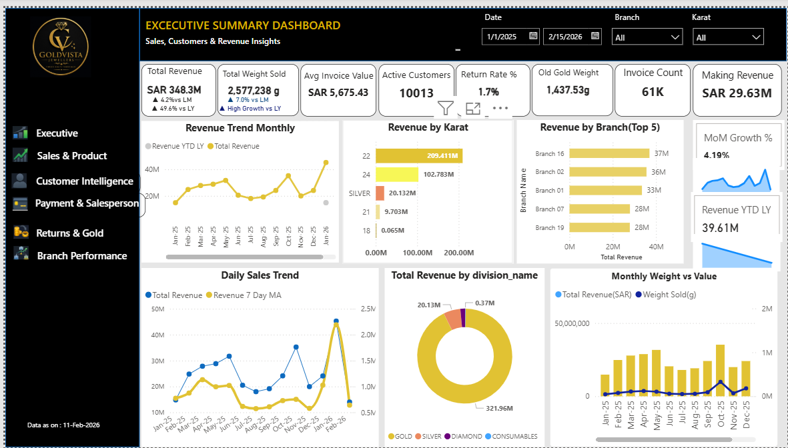
Business Questions Answered
- What is the company's total revenue?
- How many invoices were generated?
- What is the average invoice value?
- How much jewellery weight was sold?
- How many active customers purchased during the period?
- What is the return rate?
- Which branches contribute the highest revenue?
- Which karat generates the most revenue?
- Is revenue increasing or decreasing over time?
KPI Metrics
KPI | Description
Total Revenue | Total sales generated
Invoice Count | Total number of invoices
Average Invoice Value | Average revenue per invoice
Total Weight Sold | Total jewellery sold in grams
Active Customers | Unique purchasing customers
Return Rate | Percentage of returned sales
Old Gold Volume | Total old gold purchased
Making Revenue | Revenue generated through making charges
Dashboard Visuals
- Revenue Trend: Displays monthly revenue performance and identifies seasonal sales patterns.
- Revenue by Karat: Compares revenue generated across different karat categories and highlights customer preferences.
- Top Branches: Ranks branches based on total revenue contribution.
- Revenue by Division: Shows revenue contribution from Gold, Silver, Diamond, and other divisions.
- Daily Sales Trend: Displays daily sales with a moving average to identify trends and unusual spikes.
- Weight vs Revenue: Comppares physical sales volume with revenue to evaluate whether growth is volume-driven or value-driven.
Key Findings
- 22K jewellery contributes the largest share of revenue.
- Gold products dominate overall sales.
- Revenue is concentrated among a few high-performing branches.
- Return rates remain relatively low.
- Making charges contribute significantly to overall profitability.
Dashboard Features & Recommendations
- Impact: Enables executives to monitor organizational performance in real time.
- Recommendations: Increase 22K inventory, replicate top-branch practices, and strengthen campaigns.
- Features: Dynamic KPI Cards, Date Range Slicer, Branch/Karat Filters, Cross Filtering, Drill-through.
Branch Performance Dashboard
Dashboard Objective Evaluates branch-level performance by comparing revenue, transaction value, weight sold, returns, payment mix, and salesperson productivity.
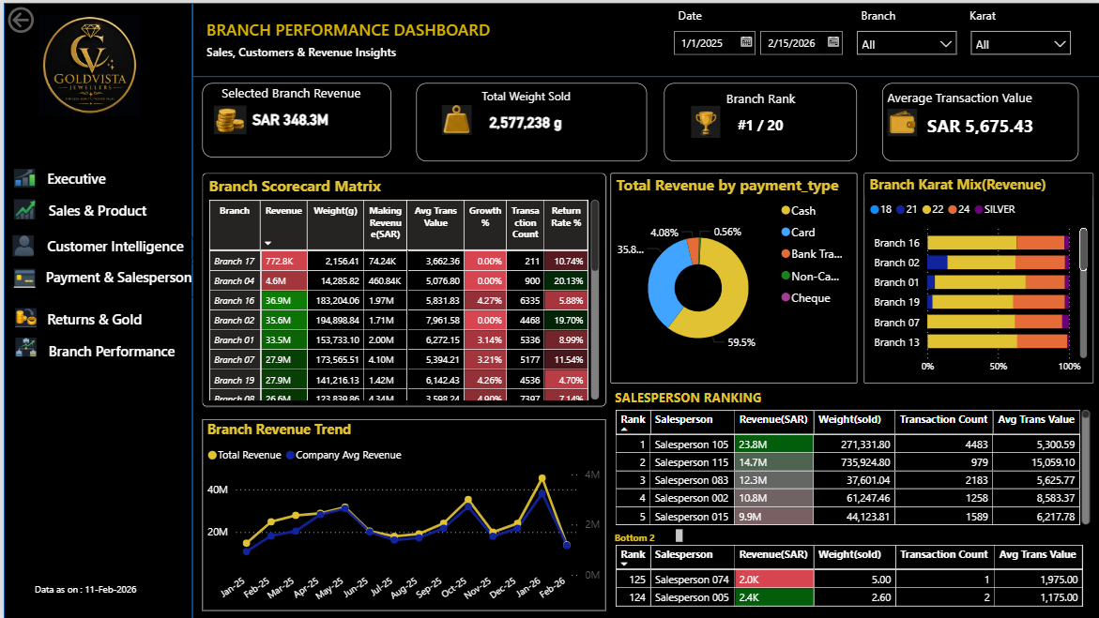
Business Questions Answered
- Which branch generates the highest revenue?
- What is the branch ranking?
- Which branch has the highest average transaction value?
- Which branches have higher return rates?
- How does payment behaviour vary by branch?
- Which salesperson performs best within each branch?
KPI Metrics
KPI | Description
Branch Revenue | Revenue generated by selected branch
Branch Rank | Revenue ranking among all branches
Weight Sold | Total grams sold
Average Transaction Value | Average invoice value
Dashboard Visuals & Findings
- Visuals: Branch Scorecard Matrix, Revenue Trend, Branch Karat Mix, Payment Type Distribution, Salesperson Ranking.
- Key Findings: Significant revenue variation exists among branches. Top branches maintain higher average invoice values. Payment preferences differ by location.
Dashboard Features & Recommendations
- Impact: Helps regional managers identify strengths and weaknesses.
- Recommendations: Benchmark top-performing branches and improve training.
- Features: Single Branch Filter, Date Slicer, Conditional Formatting, Dynamic Ranking.
Sales & Product Dashboard
Dashboard Objective Analyses product performance, item profitability, making charges, discounts, and product contribution to revenue.
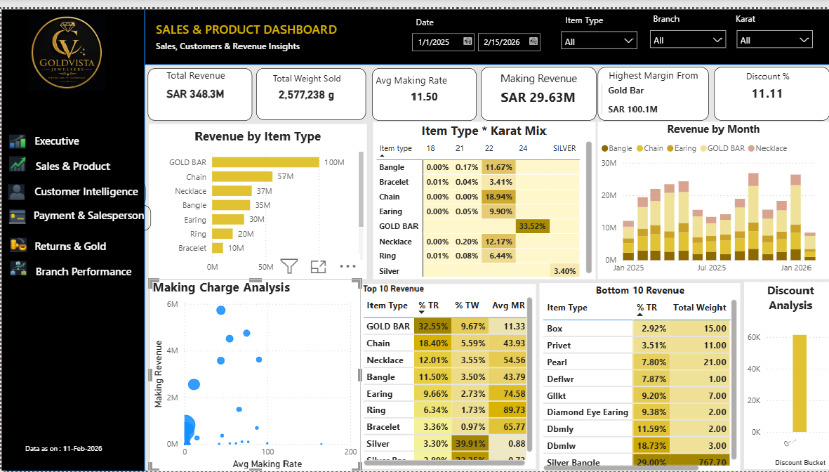
Business Questions Answered
- Which item types generate the highest revenue?
- Which karat performs best?
- Which products generate maximum making revenue or receive higher discounts?
- Which products underperform?
Dashboard Visuals & Findings
- Visuals: Revenue by Item Type, Matrix, Monthly Trends, Making Charge/Discount Analysis, Top/Bottom 10 Products.
- Key Findings: Gold Bars and Chains contribute significantly. A small number of products generate most revenue while some consistently underperform.
Dashboard Features & Recommendations
- Impact: Supports inventory planning, pricing strategy, and category management.
- Recommendations: Increase stock of high-performing products and review low-performing items.
- Features: Slicers, Interactive Matrix, Drill-down.
Customer Intelligence Dashboard
Dashboard Objective Analyses customer purchasing behaviour, segmentation, retention, and lifetime value.
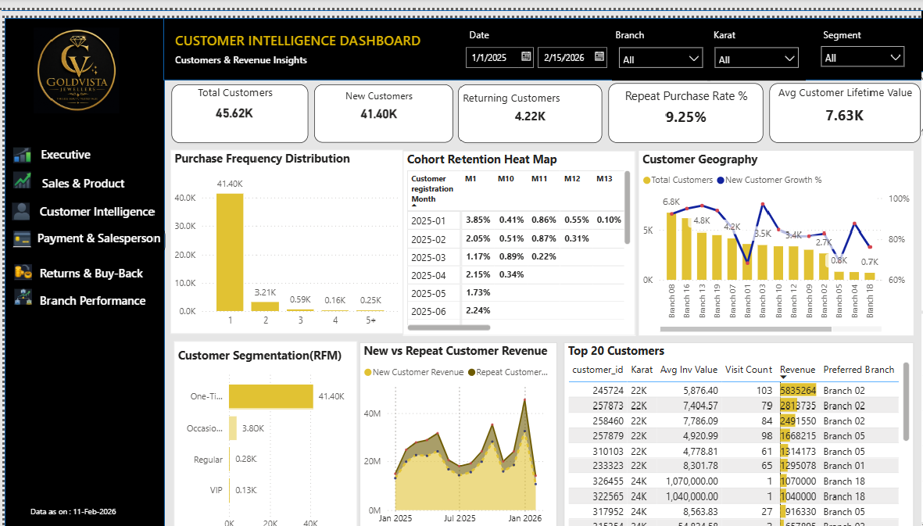
Business Questions Answered
- How many customers are active and what is the repeat purchase rate?
- Which customers generate maximum revenue?
- How frequently do customers purchase?
Dashboard Visuals & Findings
- Visuals: Purchase Frequency Distribution, Segmentation, Cohort Retention Matrix, New vs Repeat Revenue, Customer Geography.
- Key Findings: One-time customers represent the largest segment, though VIPs contribute significant revenue.
Dashboard Features & Recommendations
- Impact: Supports retention strategies and targeted marketing.
- Recommendations: Introduce loyalty programs to capitalize on the repeat purchase opportunity.
- Features: Filters, Interactive Customer Analysis.
Returns & Buy-Back Dashboard
Dashboard Objective Monitors product returns and old gold buy-back activities to support operational and financial decision-making.
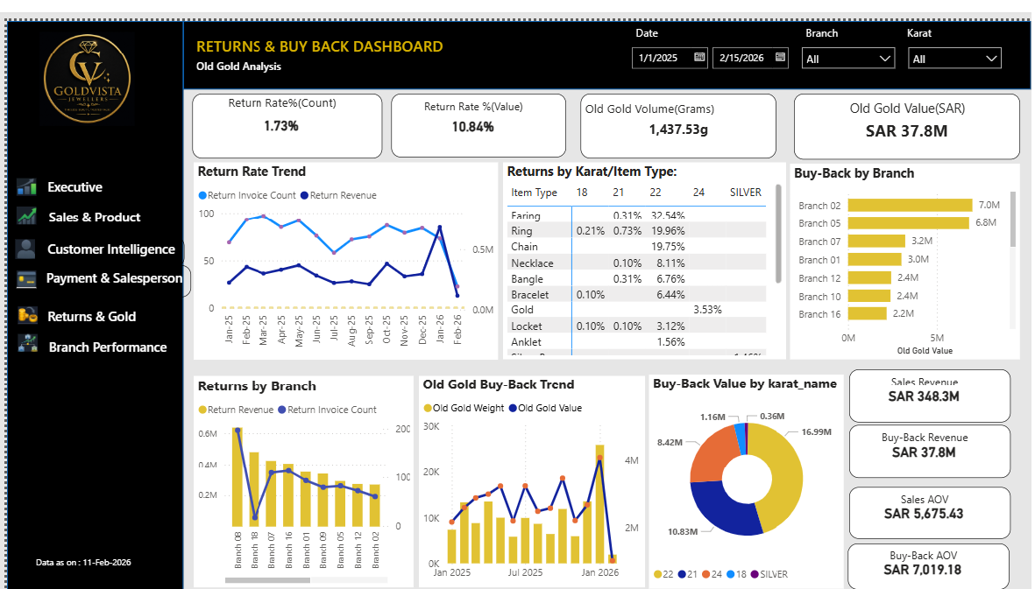
Business Questions Answered
- What is the return rate and which products are returned most?
- How much old gold is purchased and which branches contribute most?
Dashboard Visuals & Findings
- Visuals: Return Trend, Returns by Branch/Karat, Buy-Back Trend/Branch, Purity Distribution.
- Key Findings: Return rate remains low. Buy-back activity generates strong business value, heavily concentrated in specific branches.
Dashboard Features & Recommendations
- Impact: Supports quality monitoring and procurement planning.
- Recommendations: Expand buy-back campaigns and monitor branches with high return rates.
- Features: Interactive Charts, Dynamic Analysis.
Payment & Salesperson Dashboard
Dashboard Objective Evaluates payment behaviour and employee performance to improve financial management and sales productivity.
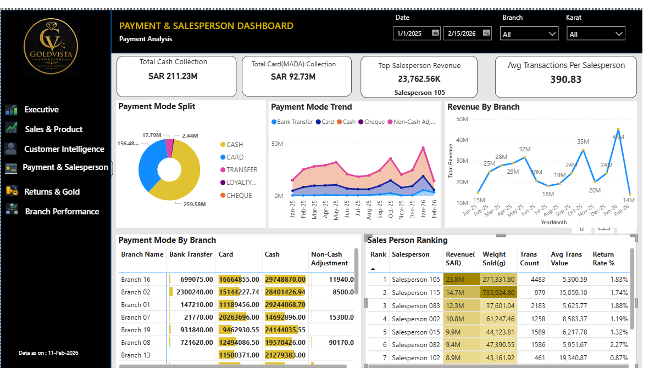
Business Questions Answered
- Which payment mode is preferred and how are they trending?
- Which salesperson generates maximum revenue and what is their average value and discount rate?
Dashboard Visuals & Findings
- Visuals: Payment Split/Matrix, Revenue by Branch, Salesperson Ranking, Discount Analysis.
- Key Findings: Cash remains dominant. Top salespersons consistently outperform their peers.
Dashboard Features & Recommendations
- Impact: Supports cash management for finance and performance tracking for sales managers.
- Recommendations: Encourage digital payments and reward top performers.
- Features: Payment/Salesperson Filters, Conditional Formatting.
10. Key Business Findings
- 22K jewellery contributes the highest revenue share.
- Revenue is concentrated among a limited number of branches.
- Customer acquisition is strong, but repeat purchases remain low.
- Cash is the preferred payment mode.
- Buy-back activity creates additional business value.
- Branch performance varies significantly across locations.
- Product profitability differs substantially by item type.
11. Business Recommendations
- Introduce customer loyalty and retention programs.
- Optimize inventory based on branch demand.
- Monitor discount practices by salesperson.
- Promote digital payment adoption.
- Expand buy-back campaigns.
- Strengthen branch performance reviews using KPI dashboards.
- Increase focus on high-margin product categories.
- Implement predictive analytics for demand forecasting.
12. Limitations
- Historical data only.
- No external gold price or market data.
- No predictive modeling.
- Dashboard reflects available transactional records.
13. Future Enhancements
- AI-driven sales forecasting
- Customer churn prediction
- Inventory optimization models
- Mobile dashboard deployment
- Automated data refresh pipelines
14. Conclusion
The GoldVista Retail Analytics project demonstrates how SQL, dimensional modeling, and Power BI can transform operational data into strategic business intelligence.
The integrated analytics platform enables executives and managers to monitor KPIs, identify growth opportunities, improve operational efficiency, and make data-driven decisions through a single, centralized reporting solution.
16. Appendix
Major DAX Measures
- Total Revenue
- Invoice Count
- Total Weight Sold
- Average Invoice Value
- Active Customers
- Return Rate %
- Making Revenue
- Old Gold Value
- Branch Rank
- Salesperson Rank
- Customer Lifetime Value
- Repeat Purchase Rate
Technologies Used
- PostgreSQL
- Excel
- Power BI
- DAX
- SQL
- GitHub

